**Autotype search ni all select box**

**Sidebar Product Section :**

**City : add & edit form autotype search country**

**Hotel, Tour , Railway & Airport : Same autotype search country and city**

**Supplier & Agent: Same autotype search country and city**

**Operational -> action -> costing & Payment : Autotype Supplier**

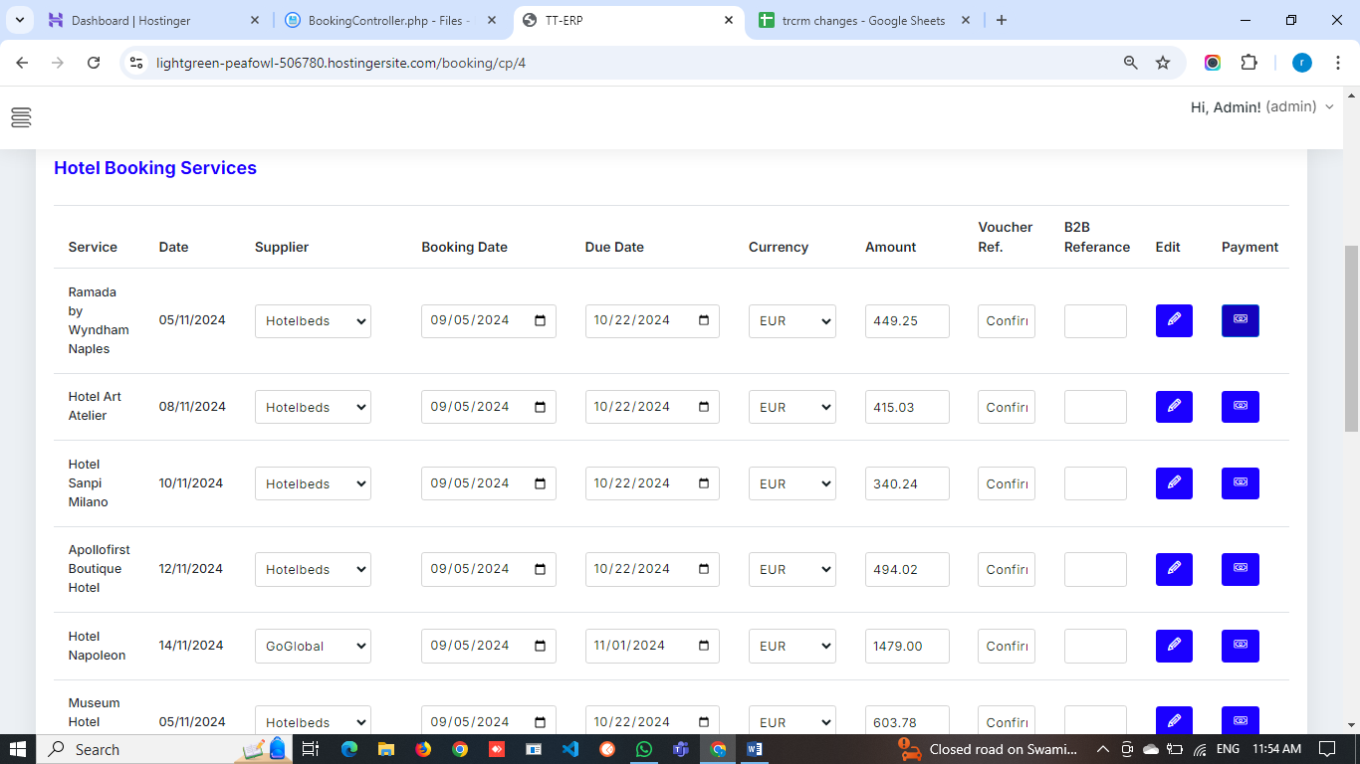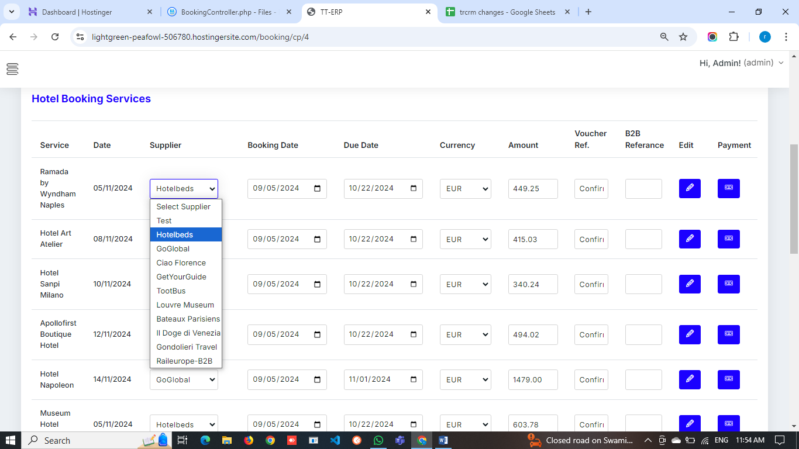**When Full this payment form color change to green**

**Attachment not working because of php artisan storage:key not generate (code ready)  
so check it upload both pdf and image and once save its display in form and when we click it download**

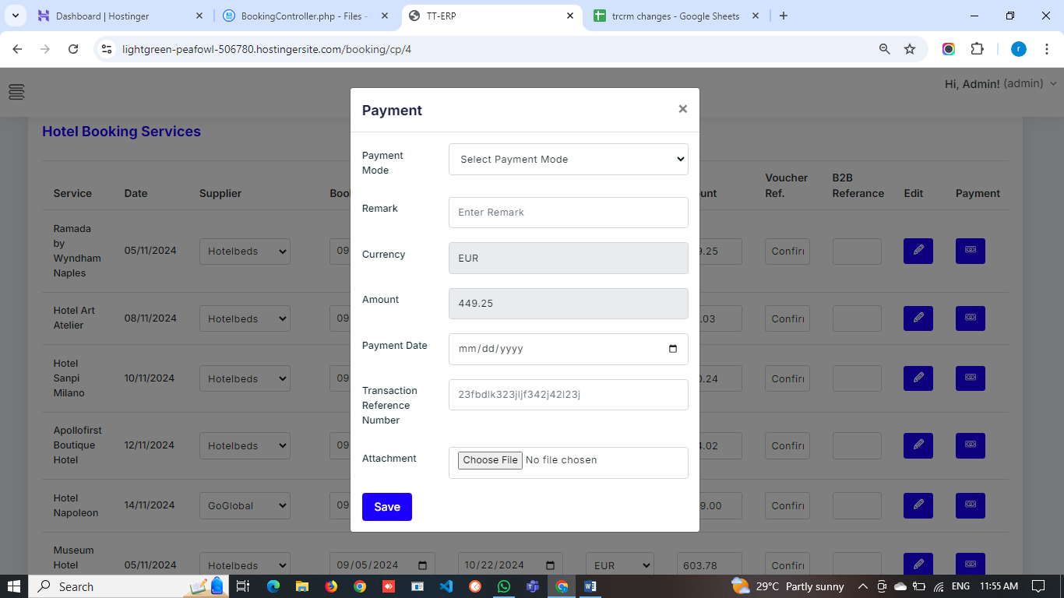**Change Calender data formet in all calender :  
mm-dd-yyyy to dd-mm-yy**

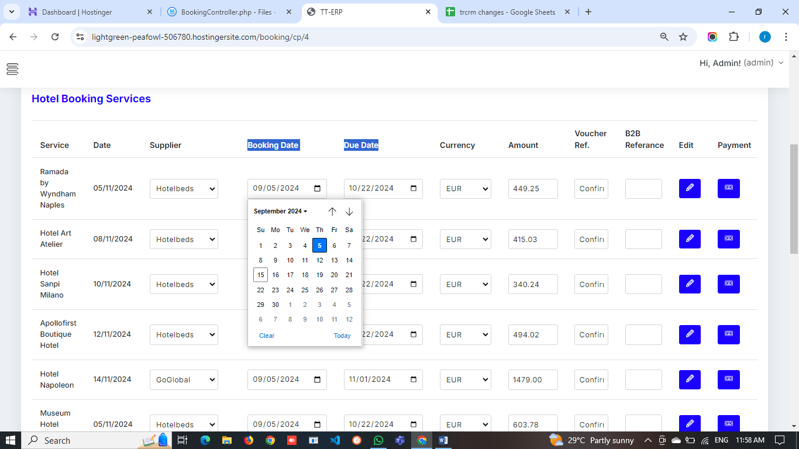

**Auto type search   
booking->action->add services :  
hotel add and edit : hotel name   
when edit change hotel name address not fetch so check it**

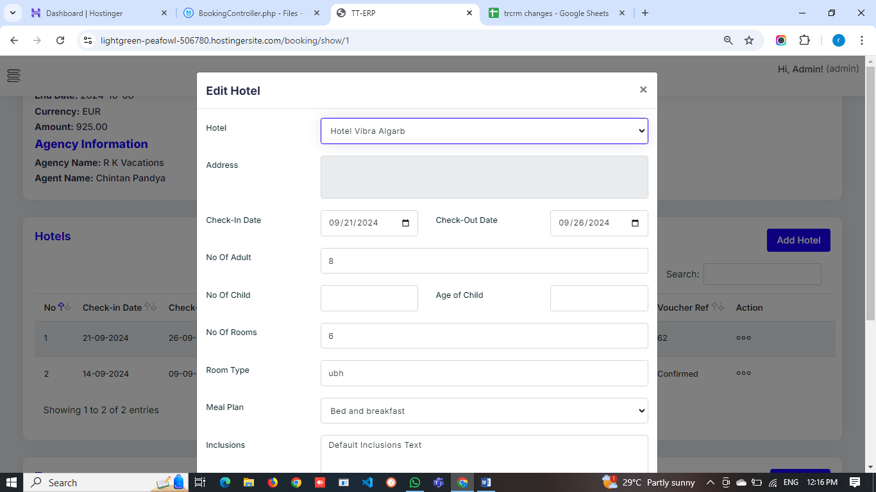 **in tour same as hotel so check it**

**transfer auto type airport, hotel and station name in add and edit**

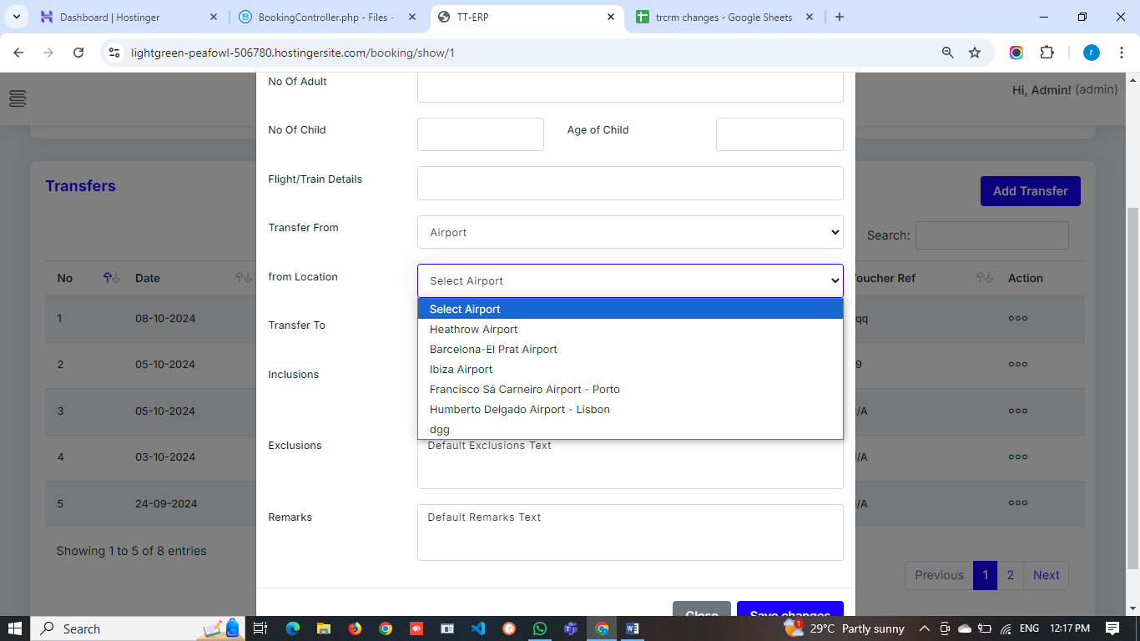**replace airport to name :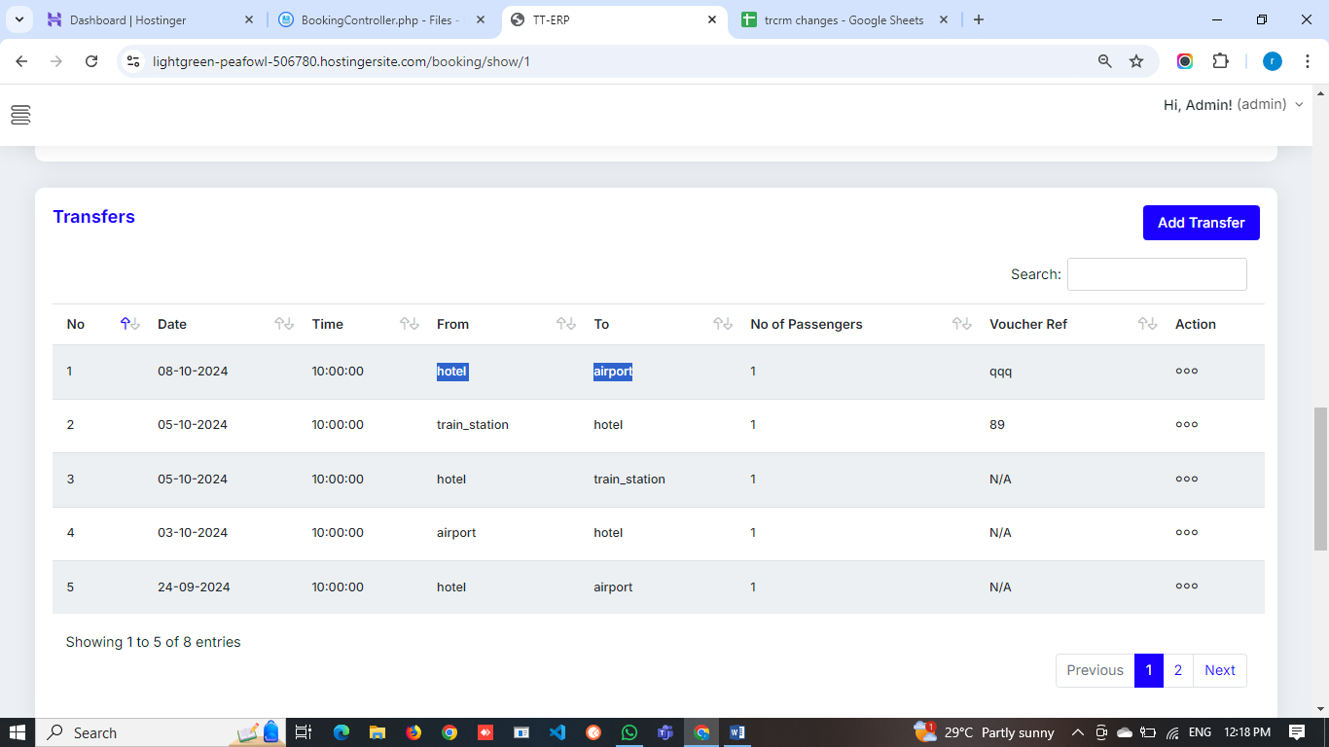misc : auto type country and city**

**Disable date : Call per   
main important * in html calender change all data select formet mm-dd-yyyy to dd-mm-yyyy  
tame ek kari aapjo ane samjavi dejo etly hu kari daies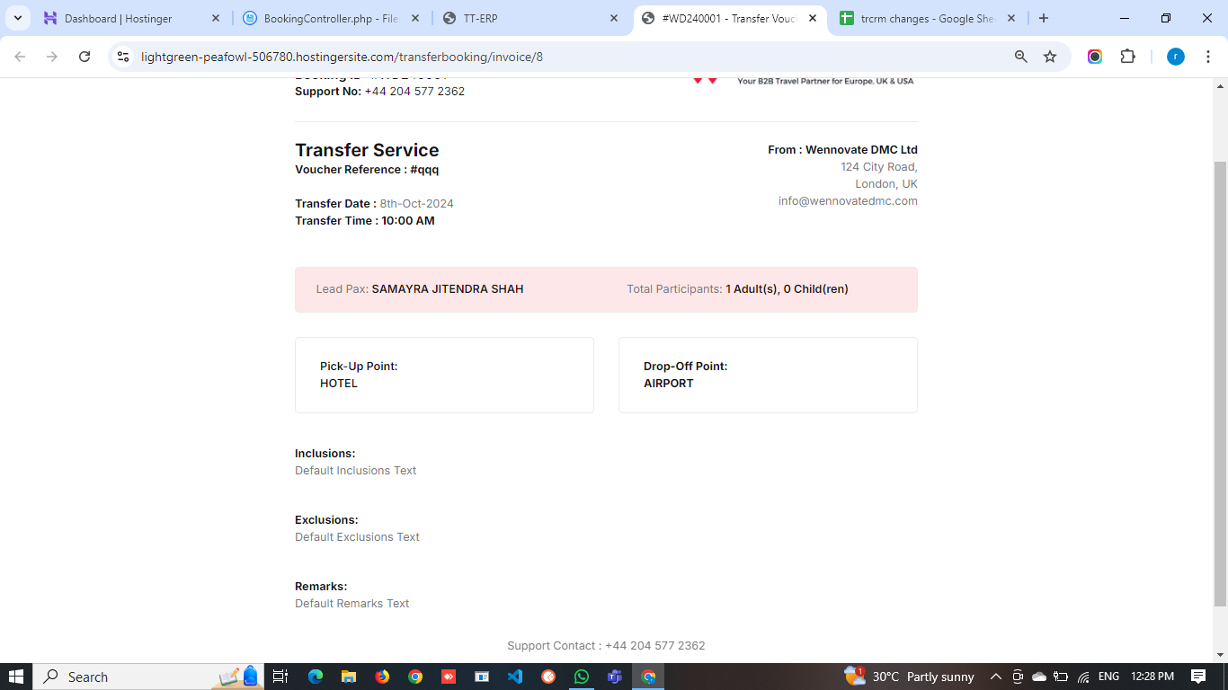transfer name change in this pdf**